 |  | 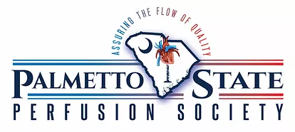
 |  | Fall 2020 Newsletter
https://www.scperfusion.org/  PalmettoPerfusion@gmail.com  PSPS 2018-2020  Board of Directors  President  Al Cain, Columbia  ​  Vice President  Dafne Chianella, Charleston  ​  Treasurer  Ken Ingersoll, Anderson  ​  Membership Chair  Mark Wilson, Charleston  ​  AmSECT State Liason  Ronnie Smith, Charleston  Web Editor  Davy Fisher, Charleston  ​ |  | 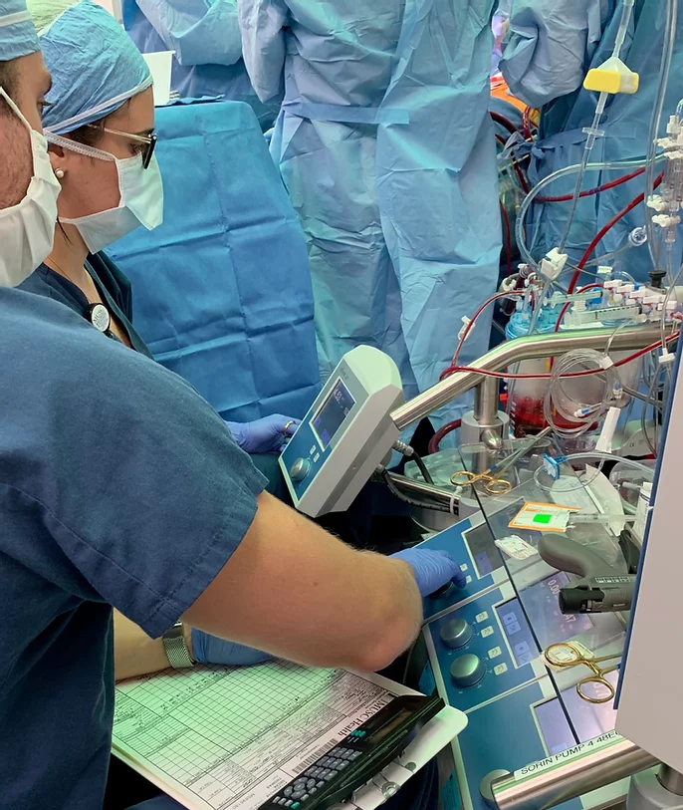  Our Mission  ​To Promote Excellence, Safe Practice, and Empowerment for South Carolina Perfusionists; Through Education and Collaboration
Fall highlights  Upcoming Events  Willingness to Serve application due October 9th, 2020  2021-2022 Board of Directors Election survey due October 23th, 2020  2021-2022 Board of Directors Election Results announcement October 24th, 2020  Update on Perfusion MUSC Conference Friday, October 23, 2020 and Saturday, October 24, 2020  Carolina Perfusion Symposium  July 30th - August 1st, 2021 |  | Letter from the President  Greetings SC Perfusion,  This is likely my last note to you all, as president of the PSPS.  When asked, in the fall of 2017, to serve as our state’s AmSECT GRC Representative’, I realized that the most effective avenue to share information of various states working toward, and achieving credentialing, as well as to gauge interest in SC, was to re-awaken our state’s perfusion society.  To briefly review: During the mid-1990s, several perfusionists, led by Tommy Mann and Jeff Acsell, chartered and organized our “Palmetto State Perfusion Society”. They then commenced on a toilsome and nearly successful, attempt to provide professional licensure for SC perfusionists. This gallant effort did ultimately succumb to intractable, yet well-meaning opposition.  Bringing PSPS back to ‘active’ status remains somewhat premised on SC credentialing, though not entirely so! Our early objectives are to fortify a sense of professional community, while providing local(statewide) continuing educational opportunities.  Here is a brief re-iteration of early efforts:  - Rekindled our profession society.  - Held and elected board officers. Next (2yr term) elections to be held in October. PLEASE consider serving!!  - Launched a local professional membership requiring dues.  - Created a professional website(scperfusion.org) …please visit today!!  - Assessed latent funding, and now provide a thorough accounting of PSPS resources.  - Sought and gained perfusion science-based industry support.  - 2019: Conducted a perfusion professional/social gathering which provided both collegial and educational benefit.  - 2020: Partnered with ‘Perfusion Life’ to provide the 1st Annual ‘CAROLINA PERFUSION SYMPOSIUM’ -which due to COVID-19- is rescheduled for July 30-August 1, 2021. Website: carolinaperfusionsymosium.com …visit the site today!  - Volunteered in numerous professionally related events and are eager to help with yours!  - Publish biannual(spring/fall) newsletters.  Though I will not be an official board officer in the future, I will have interest in strengthening our professional bonds in SC. My contact info…cell: 803-608-9761/email: cainar18@gmail.com. I am interested in every CCP or prospective CCP in this state. If you have something that you think I can help you with, please call, text, or email. Again, I am committed to working with you all, to better perfusion in South Carolina!  My very best to all,  Al Cain, CCP  President, PSPS
Willingness to Serve Form:
Name:
Employer and City:
Running for What Position:
- 1st VP/ President elect
- Treasurer
- Web Master/
Secretary
- Membership Chair
- Government Relations Committee Chair (GRC)
Personal Statement (500 word max):
Attach a photo of yourself:
Please email to:
PalmettoPerfusion@gmail.com

2020-2022 PSPS
Board of Directors Election

2020 is an election year for the PSPS Board of Directors. This is an exciting opportunity to join a motivated and empowered group, who share a common goal of supporting CCPs, students, physicians, and patients of South Carolina. The Willingness to Serve application is attached to this email, and is due by the end of September. The elections will be held via anonymous voting through the month of October. The official winners will be announced on October 24th. Anyone and everyone with a desire to participate and build collaboration is encouraged to submit an application. Support your society, and make a positive impact, by joining the PSPS Board!

Please submit all Willingness to Serve forms to:
PalmettoPerfusion@gmail.com

Member Spotlight:
Laura Dell’Aiera, MHA CCP

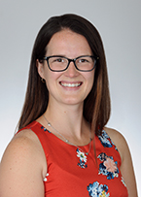

Laura Dell’Aiera joined the MUSC College of Health Professions in 2018. She attended SUNY Upstate Medical University for perfusion school and worked at University of Rochester Medical Center before joining us in South Carolina. She not only earned a Master Degree in Health Administration; she is very active in AmSECT as well. We are so fortunate to have her in our state, educating the students of tomorrow!

Interview:
Official title at MUSC and when you started:
Clinical Coordinator and Faculty Instructor

What drew you to pursue a career as a perfusion educator?
I loved working with students at the University of Rochester. They often have an infectious enthusiasm! I’ve also always appreciated the exceptional impact that certain clinical instructors and faculty members made on my life as a student. I wanted to provide that for future students.

What is your favorite part about teaching the CCPs of tomorrow? What is the most challenging part?
My favorite part is their excitement for learning and the way that they push me to continue learning. No matter how many questions you answer, someone always comes up with something new. The most challenging part is being humble enough to admit when you don’t know something and putting the effort into finding the answers.

You are in the process of earning your DHA, how is that going and how will that support your role as educator? As a perfusionist?
I personally am pursuing a DHSc with a focus in Leadership in higher education. This will be an exceptional degree for me in my role as an educator. I have the perfusion skills that I need but the teaching skills will be important to develop through this degree. As a perfusionist, I think this will help to develop Cardiovascular Perfusion as a profession and not a job. I hope to inspire other perfusionists to pursue higher degrees!

What are some exciting updates happening at the school or in perfusion education in general?
Dave and I are both visionaries. We are very happy with the way that the program is growing and developing but we both have visions of how we would like to see it continue to adapt to the future. Life in the COVID era and the new virtual world require that we adapt and improve based on the current environment. I have hopes of developing the program to be more accessible with more realistic and beneficial simulation.

Outside of perfusion and MUSC, what do you enjoy doing for fun and what is something you would like to share about yourself?
Whenever possible, I love to be outdoors. This is my way of decompressing from a stressful job and appreciating the natural beauty around us! Kayaking, gardening, scuba diving, walking the dogs, anything!

Photos: Laura with her husband Al and pups!
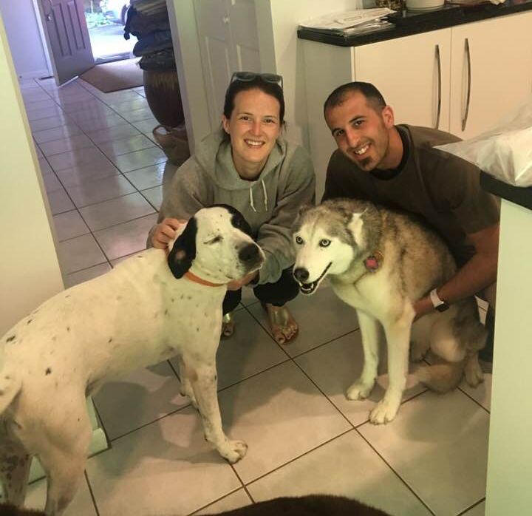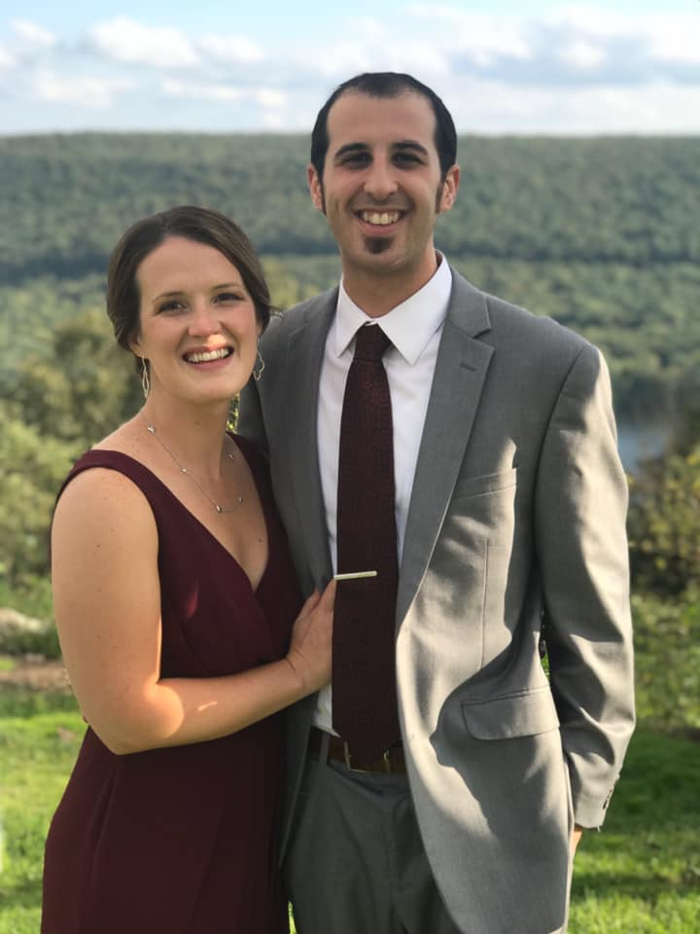
State Wide Update on COVID 19
COVID 19 (SARS-CoV-2)
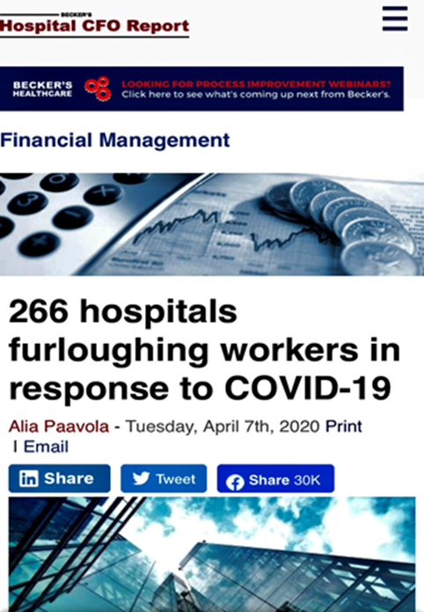

What a difference a year can make! This time last year if you were told you had Corona virus it most likely meant you had a common cold or another mild upper-respiratory tract infection. But as we all learned, SARS-CoV-2, the Corona virus that causes COVID-19, has devastated the world claiming close to one million lives worldwide, including the lives of over 200,000 Americans. Believed to have originated in Hunan, China, COVID-19 hit America with a vengeance in early 2020.
PSPS reached out to several programs in the South Carolina region to gain perspective for how COVID-19 has affected the perfusion community and this is what we learned:
- Most programs experienced a significant drop off in surgical volume after our Governor declared “emergencies only” on March 13
- One program reported a decline of 25-50 percent in March and April
- Another program reported a decline of 24% in surgical volume to date and was required to furlough two team members, one for three months and the other for 32 days
- One program was required to take a temporary salary cut of 15%. This same program actually saw an increase in surgical volume during the “electives only” phase
- Another program saw scheduled merit and market increases cancelled for the year and each CCP was required to use two days of PTO. This program saw an initial drop off of about 35% but has recovered to a 7% decline as compared against 2019 data
- Perfusion Life was forced to abruptly pull CCPs from several hospitals due to volume decline, but this was soon followed by a significant increased need for staffing and ECMO support
Needless to say, all of our lives have been disrupted by this dreaded pandemic. The good news is most programs are now reporting near normal return and many are now seeing increases in surgical volumes. We all hope and pray this trend continues.
Hopefully, many of you were able to participate in the Joint Perfusion COVID-19 Task Force, which brought together perfusionists from around the world. PSPS congratulates the task force for sharing their experiences and keeping us informed.
Thank you to Inova Healthcare, Lexington Medical Center, MUSC Health, Perfusion Life, Providence Health and Roper Hospital for contributing to this report.
Please visit scperfusion.org forum page to share your team’s story!

 |  | PSPS News:
July 30-Aug 1, 2021  Expecting at least 15 ABCP Category 1 CEUs |  | Rescheduled for 2021!  Like many other events, meetings, and conferences around the country, PSPS made the decision to delay the much-anticipated Carolina Perfusion Symposium. The new date is July 30th-August 1st, 2021, and will be held at the Marriott Myrtle Beach Resort and Spa at Grande Dunes. This beautiful facility is the perfect location for the state society conference. We are excited to have Dr. Dave Fitzgerald, MUSC Cardiovascular Perfusion Program Director as the Key Note Speaker. In addition, the program will be full of interesting talks and influential physicians from around South Carolina. Some of the topics include safety, teamwork, current trends in adult cardiac surgery, and the future of perfusion. This is a fantastic opportunity to collaborate and learn from other centers within our own state.  -Are your surgeons doing laser lead extractions with perfusion standby?  -What is everyone doing for ECMO?  -How are you handling the cannula shortage?  -and more!!

Marriott Myrtle Beach Resort & Spa at Grande Dunes

About the Resort:
Discover an oceanfront oasis at Marriott Myrtle Beach Resort & Spa at Grande Dunes. Our AAA-rated Four Diamond resort is optimally situated on the north end of Myrtle Beach. When you're ready to venture out, find championship courses at Grande Dunes and nearby entertainment at Barefoot Landing and Myrtle Beach Boardwalk. Enjoy all-day dining and delicious international cuisine while you admire ocean views at our on-site restaurants and bars. Bask in the sun, play in the surf or take a dip in our indoor and outdoor pools. At Hibiscus Spa, find a full menu of wellness services and maintain your gym routine at our complimentary health club. Our luxury hotel also boasts 45,000 square feet of venue space, perfect for all types of events from intimate to grand. Our family resort showcases spacious hotel rooms and suites with luxury amenities. Relax in rooms that offer private balconies and scenic views of the beach and ocean. We look forward to welcoming you to our Myrtle Beach resort.

Volunteer Opportunity

Charleston Congenital Heart Walk
The Congenital Heart Walk series directly supports the mission of The Children’s Heart Foundation: to fund the most promising research to advance the diagnosis, treatment, and prevention of congenital heart defects (CHDs). The 2020 Congenital Heart Walk series will raise critical research funds in 27 cities around the U.S., bringing together 15,000 walkers, hundreds of teams and thousands of donors in the fight against CHDs. Come join us for the walk, family-friendly activities and entertainment, and the chance to strengthen our community. With your help, we are Placing Children at the Heart of Research.
Please join us! Visit the Event Details page for more information.
https://give.childrensheartfoundation.org/site/TR?fr_id=1096&pg=entry

22nd Annual Update on Perfusion Conference
When: Friday, October 23, 2020 and Saturday, October 24, 2020
Location: Online
Continuing Education Credits:
The 22nd Annual Update on Perfusion Conference has been approved by the American Board of Cardiovascular Perfusion (ABCP) for a total of 15.6 Category 1 continuing education units.
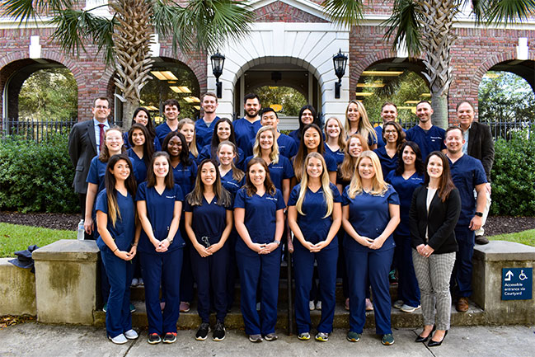
Conference Details:
Due to the unpredictable nature of the COVID-19 pandemic and the approaching Fall season, the MUSC Update on Perfusion Conference Faculty and Staff have elected to postpone this year’s onsite conference. This decision was not taken lightly, as we value the relationships built over the last 22 years hosting our clinical colleagues and industry partners in Charleston. While your health and safety is our highest priority, we also recognize that many of our delegates will be unable to travel or receive reimbursement for attending CEU hosted events for the remainder of this year. Furthermore, we want our attendees to enjoy all of the amenities that our beautiful city has to offer without concerns for their health and well-being.

To continue to meet your CEU needs, we will be hosting a virtual Update on Perfusion program on Friday & Saturday October 23rd and 24th, 2020. A modified program with times and topics will be forthcoming. Registration fees were reduced to ensure delegates receive an affordable and quality learning experience. This conference
As always, thank you for choosing MUSC for your continued learning needs.
Conference Agenda
View the 22nd Annual Update on Perfusion Conference Agenda
Registration open!
Registration is now offered at a reduced rate of $150 for the full conference, or $75 per day if you do not want the full conference experience for both Friday & Saturday. Registration for this virtual conference will remain open until the conference. Register today to secure your spot!
Register for 2020 Perfusion Conference
Exhibitor Registration

PSPS MEMBERSHIP
And don't forget to renew your membership!
$50.00 for 1 Year Membership
**SPECIAL OFFER**: $85.00 2 Year Membership with a PSPS T-Shirt
see the PSPS website for more details
https://www.scperfusion.org/
